**Documentation Phase-5 Main Project**

**Name: Anil Kumar Verma**

**Git url:** https://github.com/akv272161/Anil-Kumar-Verma

**DESCRIPTION**

**Project objective:**

As a developer, deploy your Spring Boot application on Cloud.

**Background of the problem statement:**

You have been assigned a new task during the sprint planning. You have been asked to deploy your Spring Boot application on the Cloud. You need to create and launch an instance, provide all the required privileges, and run your application.

**You must use the following:**

● Cloud: AWS

**Following requirements should be met:**

● A few of the source codes should be tracked on GitHub repositories. You need to document the tracked files which are ignored during the final push to the GitHub repository.  
● The submission of your GitHub repository link is mandatory. In order to track your task, you need to share the link of the repository in the document.   
● The step-by-step process involved in completing this task should be documented.

**Using following steps:**

**Step1:**

**Open amazon AWS on lab and open EC2 instance and create a instance**

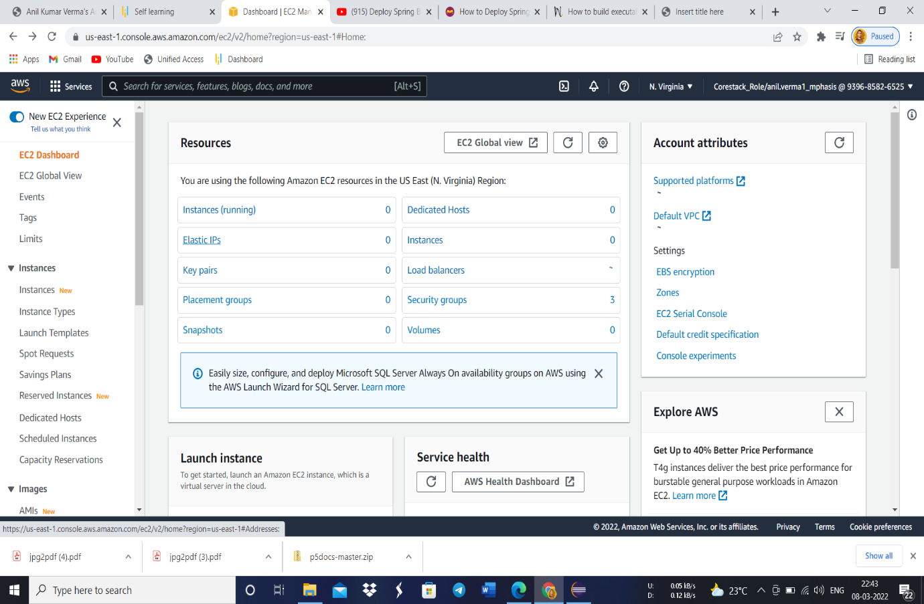

**Step2:**

**After that connect EC2 instance with Putty application.**

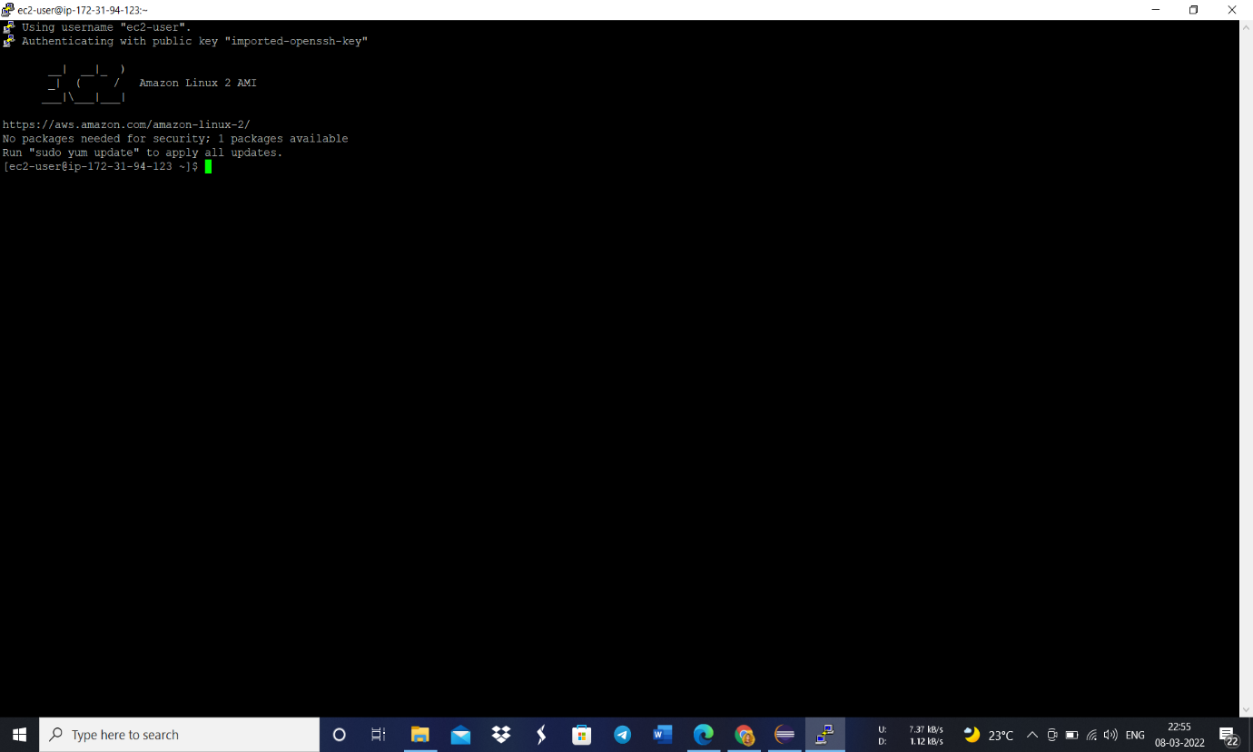

**Step3:**

**Check your java version of your Spring boot Application and install same java version using below command**

sudo yum install -y java-11-amazon-corretto-devel

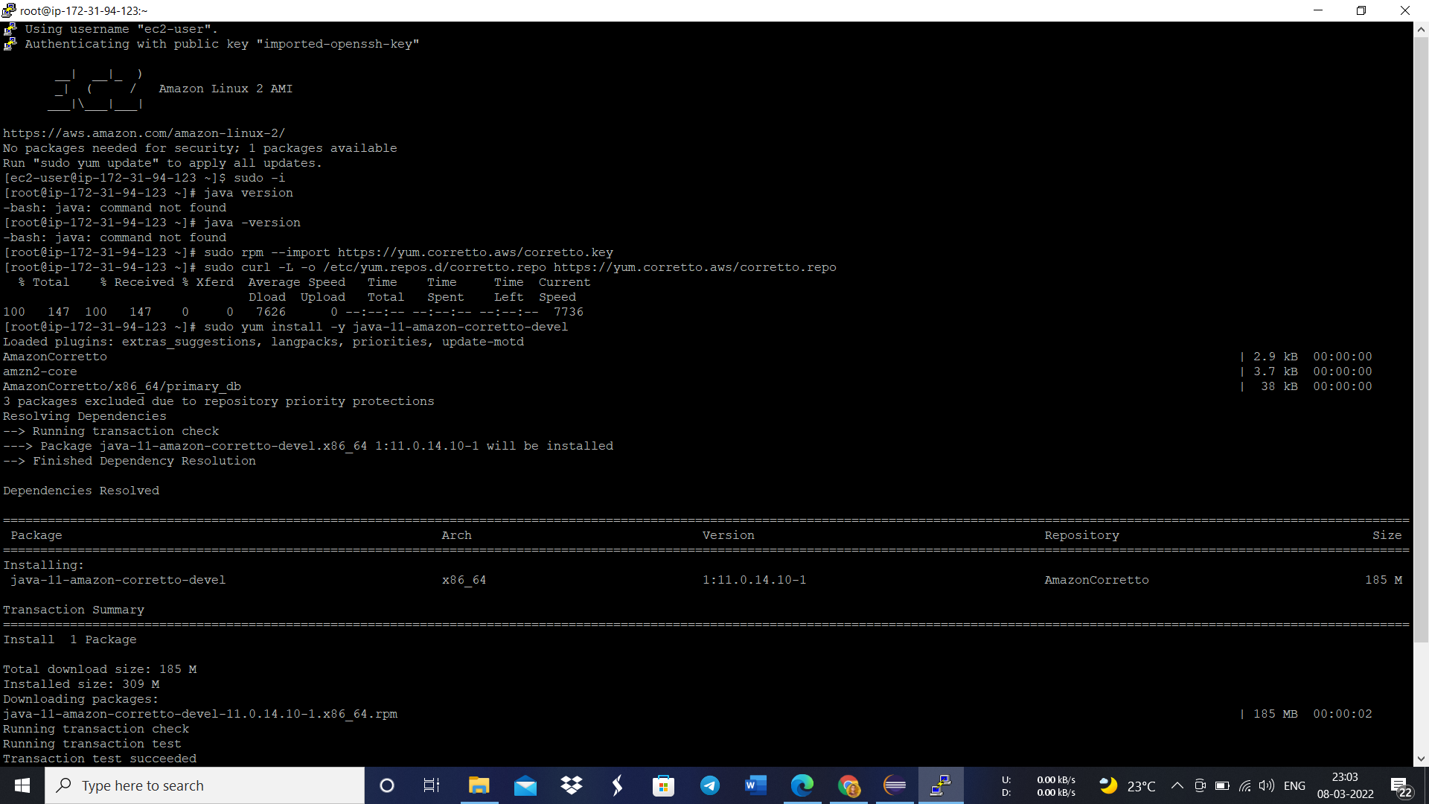

**Step4:**

**After that create a bucket and make it public and upload executable jar file of spring boot application.**

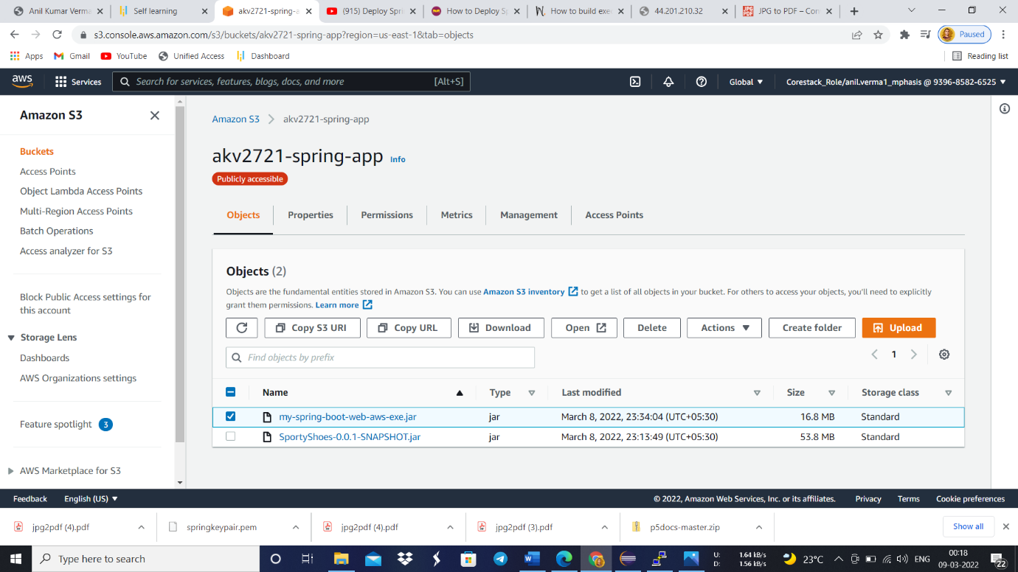

**Step5:**

**After adding jar file in bucket just run below command**

* wget https://akv2721-spring-app.s3.amazonaws.cm/my-spring-boot-web-aws-exe.jar
* java -jar my-spring-boot-web-aws-exe.jar

